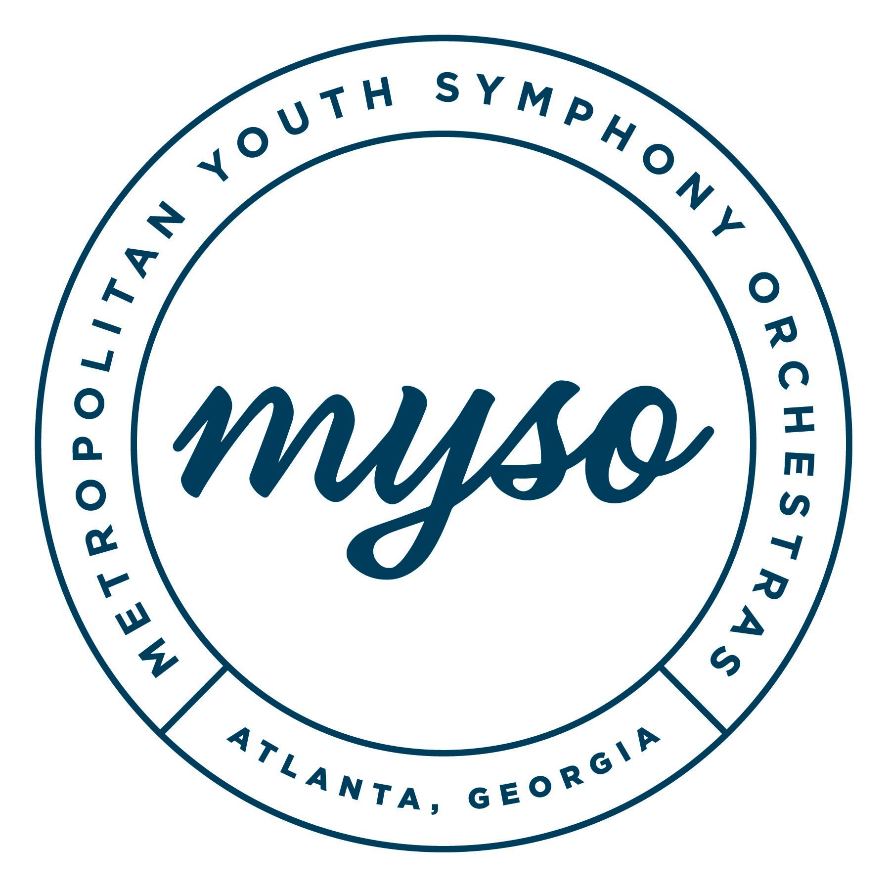

**2025-2026 SEASON SCHEDULE**

**subject to change**

**Concert Dates:**

Concert 1: November 2 at GT Ferst Center for the Arts

Concert 2: February 8 at GT Ferst Center for the Arts

Concert 3: May 3 Rialto Center for the Arts

**Rehearsal Dates:**

***Location: Drew Charter School***

*Sinfonietta: 1:45-2:45PM*

*Philharmonia: 3:00-5: 15PM*

*Symphony: 3:00 - 5:30 PM*

August 24- Family Meeting- Sinfonietta & Philharmonia 3pm, Symphony 4:15pm

August 31: No Rehearsal – Labor Day

September 7: Rehearsal – Sinfonietta 1:30-2:30pm, Philharmonia 2:45-6pm, Symphony 1-6pm

*September 7: Tuition Due!*

September 14: Rehearsal

September 21: Rehearsal (Symphony Sectionals)

September 28: Rehearsal

October 5: Rehearsal (Symphony Sectionals)

October 12: No Rehearsal

October 19: Rehearsal- Soon Hee Newbold clinic, Sinf / Phil dress rehearsal

October 26: Rehearsal Sym dress rehearsal

November 2: **Concert #1 at Ferst Center**

November 9: Rehearsal

November 16: Rehearsal

November 23: No Rehearsal- Thanksgiving

November 30: Rehearsal(Symphony Sectionals)

December 7: **Rehearsal and HOLIDAY PARTY**

December 14: No Rehearsal – Winter Break

December 21: No Rehearsal – Winter Break

December 28: No Rehearsal- Winter Break

January 4: Rehearsal

January 11: Rehearsal (Symphony Sectionals)

January 18: No Rehearsal- MLK Day

January 25: Rehearsal Sinf / Phil dress rehearsal

February 1: Rehearsal- Naima Burrs rehearsal Sym dress rehearsal

February 8: **Concert #2 Ferst Center-** Naima Burrs guest conducting

February 15:Rehearsal

February 22: Rehearsal

March 1: Rehearsal (Symphony Sectionals)

March 8: **No rehearsal - All State Weekend**

March 15: Rehearsal

March 22: Rehearsal (Symphony Sectionals)

March 29: Rehearsal

April 5: No Rehearsal- Spring Break/ Easter

April 12: Rehearsal

April 19: Rehearsal Sinf / Phil dress rehearsal

April 26: Rehearsal Sym dress rehearsal

May 3: **Concert #3 - Concerto Winner concert-**  Yukiko Nishimura premiere

**Other Important Dates:**

August 24, 2024: Student & Parent Meeting

● Philharmonia and Sinfonietta at 3pm

● Symphony at 4:15pm

September 7, 2025: Tuition final payment deadline

**2025-26 Scholarship & Concerto Competition Dates**

February 8 : Concerto/Scholarship Competition Applications and video submission due

May 3: Spring Concert, Scholarship winners certificates given, Concerto Competition Winner performs